Agent info
Game documentation

The game has 7 levels
1. Intro/tutorial level
-cutscene
2.
3.
4.
5.
6.
-cutscene
7. Boss/end level
*if running out of time we can cut the levels short, but the cut-scenes and first and last levels remain intact

-completes game? Good ending, average scores, awesome ending, best scores.

ENEMIES:
Classes of enemies: Ranged shooters, Kamikazie Enemies, Melle/Close Combat enemies.
Enemy types:
Bots: close combat
Turrets: ranged shooters
Turret bots: ranged shooters with chase ability
Trolls: melle/close combat enemies
TinyMushroomType enemies: kamikazie
Bomb bots enemies: kamikazie

NPC:
Types of NPC’s: Static and Moving
Static enemies just stay at a set place, Moving enemies move around the map. But stop movi ng once interacted with and when finished talin the continue walking.
The NPC’s the player will talk to are all Static.
The npc’s and enemy movement logic vary drastically.

Gameplay:
- Genre: 3d platformer with free-flow combat and puzzle-solving.
- Core mechanics:
- Combat: Free-flow combat system allowing smooth and dynamic fights against enemies and bosses.
- Movement: Inspired by astro bot and mario 3d games, featuring fluid movement, precise jumping, double jump, and dash.
- Puzzles: Integrated into platforming challenges, requiring players to solve them to progress.

Agency room
- When the player selects new game or continue, they start in the agency room, a central hub where they can prepare for missions.
- Objects & characters in the agency room:
- Agency boss – gives missions and story progression.
- Player – the agent ready for action.
- Arcade machine (computer) – likely used for accessing mission logs, training, or upgrades.
- Teleportation machine (undecided) – serves as a mission select and fast-travel system.
- Exit door – leads to main menu.
- Decorations – adds life and personality to the room.
- Agency boss desk – where the agency boss interacts with the player.

DIALOGUES:

LEVEL1:
[Between Player and the Chief of the agency]

LEVEL2:

LEVEL3:

LEVEL4:

LEVEL5:

LEVEL6:

LEVEL7:

Levels:
SM - spy mission (exploration)
PS - puzzle solving
CB - combat

Level 1: Introduction/tutorial level (Training-Ground)
- Gameplay: SM, PS AND CB
- Objective: Find pickups/stuff/keys in the level, fight the agency dummy bots, solve puzzled and find the machine taking you back to use it.
- Mechanics:
  - Combat: Fight prototype bots/dummy enemies and clear the area
  - Puzzle: Unlock a secure room using keys, pickups found during the mission.

Level 2: The city
- Gameplay: SM and PS
- Objective: Find designated npc’s and talk to the (ps. All npc’s can b spoken to) and talk to them about disinformation, as they have been deceived by the mayor and his disinformation tactics… Convince them about disinformation and then find puzzles and info and the carefully hidden teleportation machine that will take you back to base;
- Mechanics:
  - Exploration: Find npc’s unlockebales, pickups and the machine.
  - Puzzle: Unlock chests and use information gathered to find the teleportation machine.

Level 3: The fake news factory
- Gameplay: SM, PS and CB
- Objective: Destroy a propaganda factory full of bots that are spamming fake news. Find and defeat mini boss,he will explode and turn to the teleportation machine.
- Mechanics:
  - Combat: Fight through enemy-controlled rooms, dealing with enemies, turrets, and traps.
  - Exploration: Find and destroy marked machines, searching for hidden areas with bonus rewards.
  - Puzzle: There’s puzzles in the level.

Level 4: The campaign
- Gameplay: PS and little SM
- Objective: in a crowd locate and arrest/defeat agents of the mayor that have been sent to spread disinformation in a campain ground, find clues for locating the teleporter back home
- Mechanics:
  - Spy/stealth: sneak and find the agents of the mayor and arrestthem
  - Exploration: find the agnets and the machine taking you back to base

Level 5: The EchoChamber
- Gameplay: Lots of CB, PS and little SM
- Objective: Teleport to one of the smaller islands around the main island that the mayor has kidnapped some citizens in order to indoctrinate them, defeat the enemies there, defeat the mini boss guarding the place and release the captives.
- Mechanics:
  - Puzzle: Solve intricate puzzles to unlock doors.
  - Exploration: Discover hidden places and be rewarded with pickups.
  - Combat: fight the bots and the mini boss.

Level 6: The final broadcast
- Gameplay: SM
- Objective: Stop the rogue mayor from broadcasting his final propaganda piece to the public by sneaking into his broadcast station and finding the rooms to shutdown the broadcast.
- Mechanics:
  - Exploration: Search for hidden control rooms to shut down the broadcast system.

Level 7: Boss battle
- Gameplay: CB
- Objective: Get transported to the boss’ island, fight through hoards of monsters and defeat the boss.
- Mechanics:
  - Combat: Fight your way through an army of the mayor’s minions, and fight the boss too.
  - Exploration: Find the boss.

Narrative:
In a world where truth is a weapon, the Information Management Agency (I.M.A.), a division of the World Agency of Cool Stuff (WACS), is tasked with protecting the flow of accurate information.
You play as a top agent of i.m.a., assigned to the most critical mission yet: Taking down a rogue politician who was once a beloved mayor of wonder island.
Once a respected leader and trusted ally of WACS, the mayor fell from grace while campaigning for a second term. Desperate to reclaim power, he turned to deception—spreading disinformation, manipulating public opinion, and using fake news to control the people of wonder island. Now, with elections looming, his influence is stronger than ever, and his grip on the truth is suffocating the island.
Many agents have tried to stop him. All have failed.
But you? The agency believes you are different. Special.
Your mission: Uncover the truth, dismantle his network of lies, and take him down before it's too late.
The fate of wonder island—and perhaps the world—rests in your hands.

User interface:
The gameplay relies heavily on the UI so it’ll be a gameplay focused design.
Main menu:
First will be the main menu
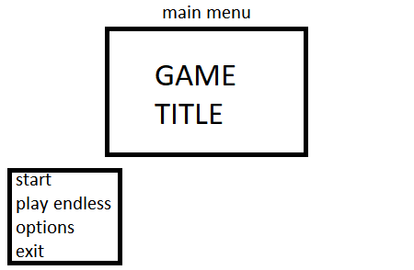

The start game button will open a panel the player will use to either start a new game, or continue an old save file
The play endless button will open a scene containing the endless mode of the combat of the game, basically a rouge-like room/dungeon where the player plays fights enemies collects power ups and does mini-games.
The options button opens an options menu
The exit button quits the game

Start menu:
Wen the start buton is clicked this is what opens
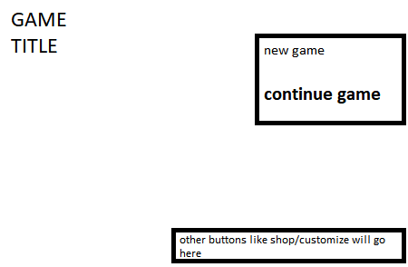

New game opens the agency room level with all the players previous data and savings and setting gone
Continue game continues with their save data to the agency room

There’s also a quit button (not shown above) and a couple other undecided buttons (shop/customization).

Options menu:
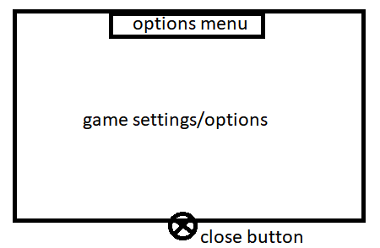

Mini game menu:
To avoid clutter and dstraction the mini game will be designed in a way that allows the player go straight to what they’re supposed to be doing.
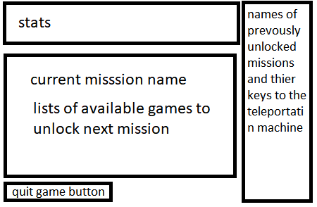

The stats sow the player stats on the mini game, highest score, number of plays, fastest win… All that stuff
The right side bar will have a list of the unlocked missions and their keys in case the player wants to go back and replay that level
The main panel will contain buttons of the mini games that are available or that should be played to unlock te level
Then the quit buton lol

Pause menu:

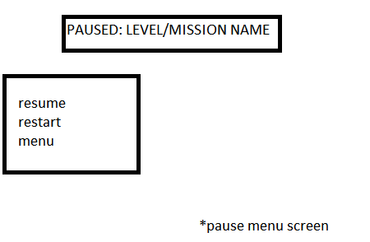
Intuivie and simple to understand

Death/Game over screen:
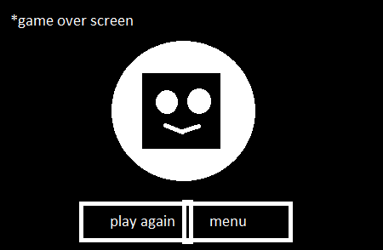

Copying astro bots iconic death screen>>>

Gameplay UI

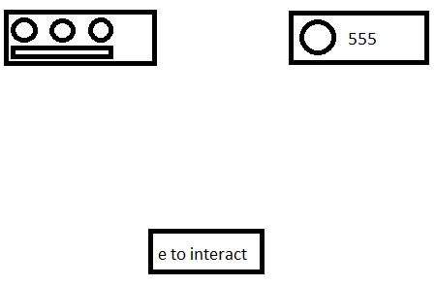

The icons on the top left: The 3 circles will be the head image of the player character. The health bar will be switch for a hollow knight style of health display. The players head. Then the stamina bar will be below.
The one on the right is the coin counter, it is ususlayu hiodden from dispolay until the player collects a coiin, pupop or defeats an enemy or boss and is rewarded.
E to interact shows up when the player is interacting with interactable objects.

